**Virtual Private Network**

VPN is used to establish the private connectivity. There are two types of VPN

Point to Site: Used to establish a connectivity between a device and a network 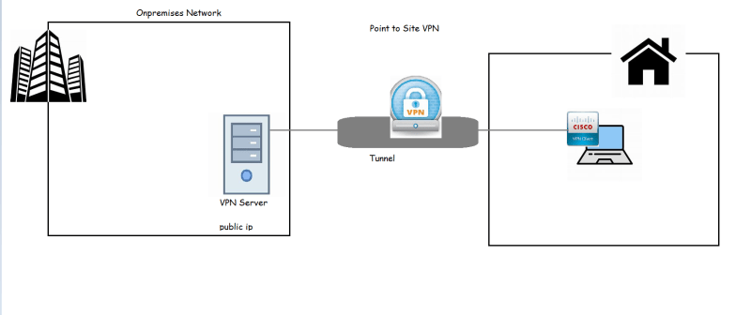Site to Site: Used to establish a connectivity between two networks

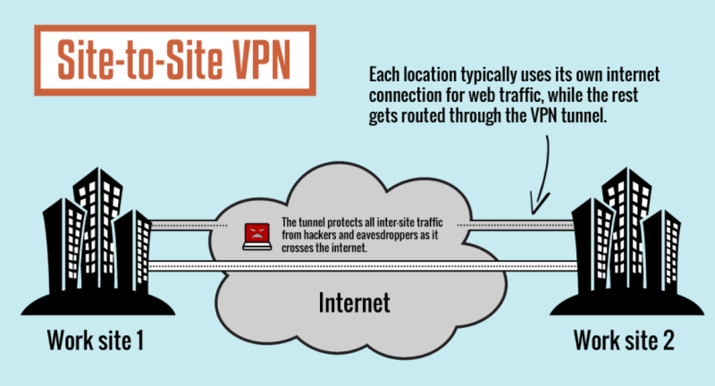

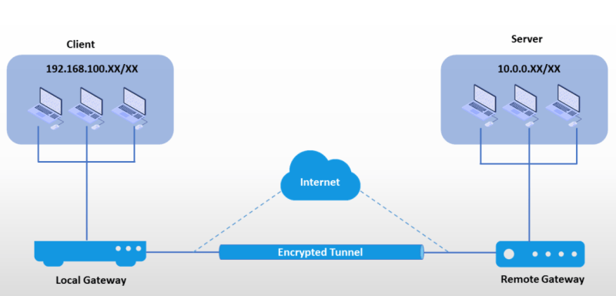

In AWS, to realize the Site-to-Site VPN 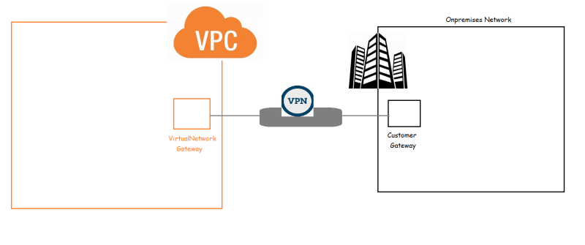

* So lets assume your organization has a cisco vpn at public ip 5.5.5.5
* Create a vpc with two subnets web1 and web2
* Create an internet gateway and attach it to vpc
* modify the route table
* Now create the customer gateway 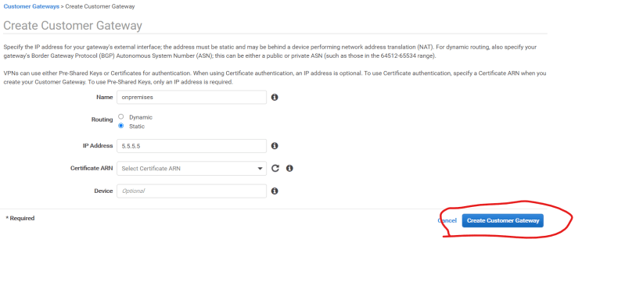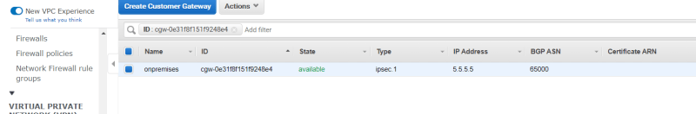
* Now create the virtual Private gateway and attach it to the vpc 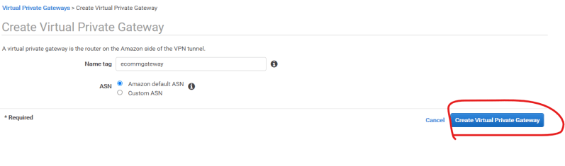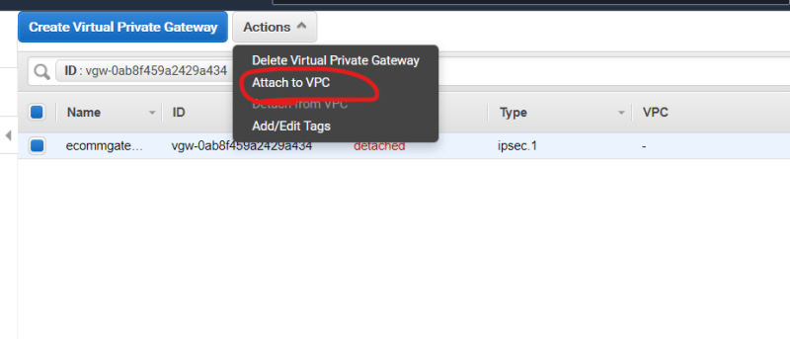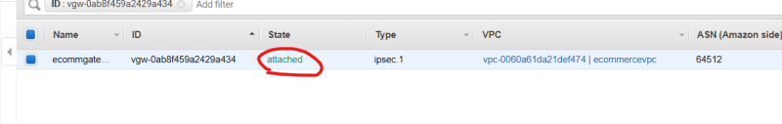
* Now create a site to site vpn connection 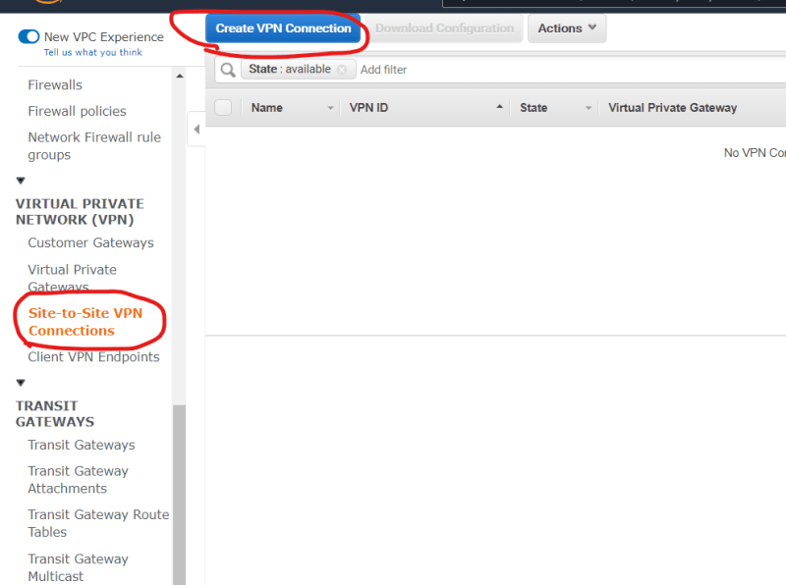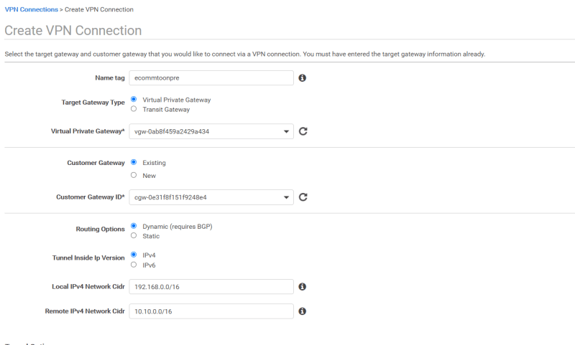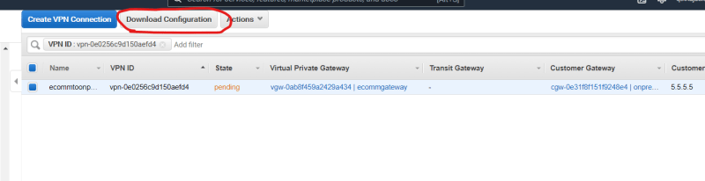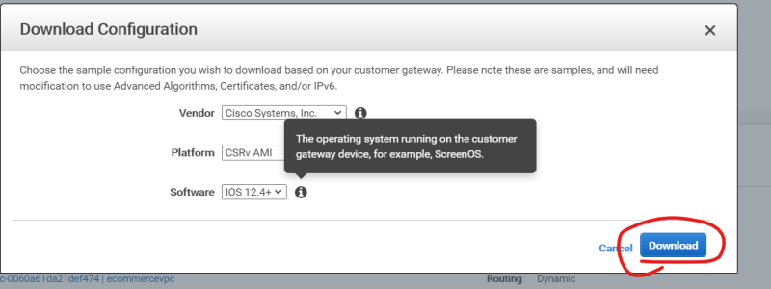
* Once the configuration is downloaded then try to configure the customer gateway to connect to vpn gateway. 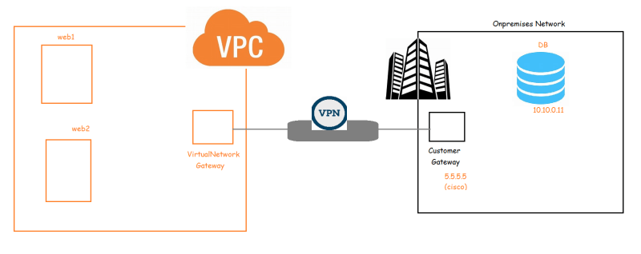
* We will be using Transit gateway to connect multiple vpc’s to onprem network 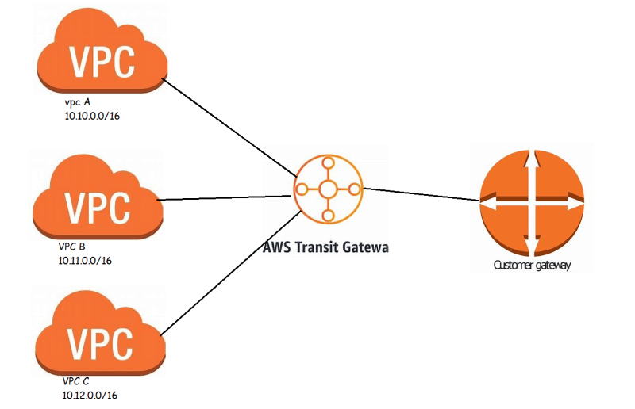

**AWS Global Network**

* AWS has a large backbone network called as AWS Global network which connects every region and Point of Presence (Edge locations) 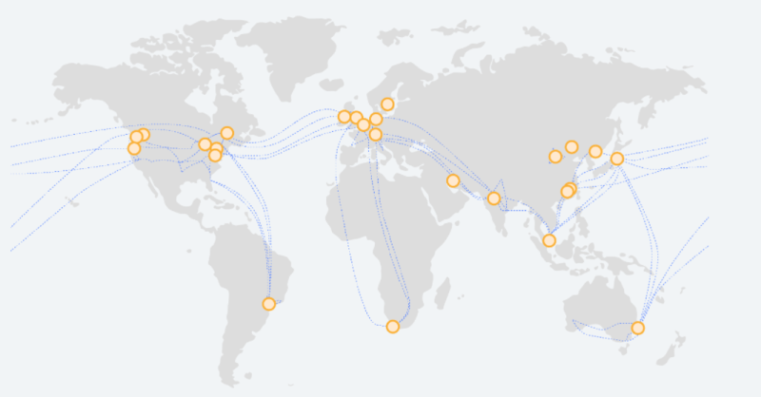
* AWS has lot of edge locations 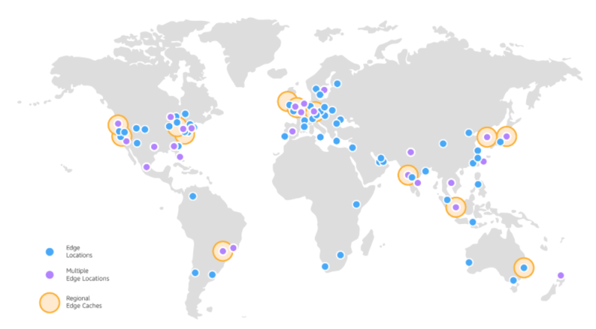
* We can use the global network and edge locations to establish dedicated connectivity from on-premises to AWS using AWS Direct Connect 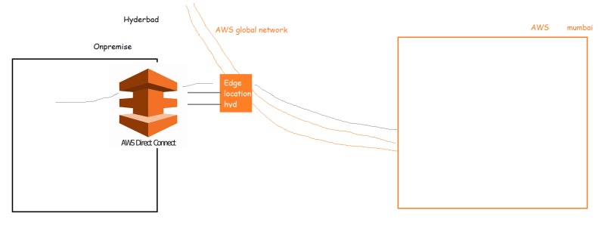

**AWS CLI Querying**

* IN AWS to query the CLI responses we can use JMES path Link: <https://jmespath.org/>
* Try to use tree viewer Link: <http://jsonviewer.stack.hu/> to understand json hierarchy and build simple paths

aws ec2 describe-vpcs --query "Vpcs[*].VpcId"

aws ec2 describe-security-groups --query "SecurityGroups[*].GroupName"

aws ec2 describe-subnets --query "Subnets[*].SubnetId"